

Summer Break

We wish each of you a summer vacation

that’s a perfect mix of relaxation and adventure,

with plenty of opportunities for fun & exploration.

We will be ready to welcome you back in October!

It’s time to pick up your **GOLF CART PERMIT!**

* Display sticker on cart windshield-lower left corner
* Cart must be insured – annual renewal sent to the office
* Turf friendly tires required
* Cart must be properly maintained
* Please buddy up to help improve turf health & quality

Please see Tiffany in the office to pick up permit ASAP!





**Michelle officially retired**

**On May 2nd**

**We wish her the best!**



**Welcome Tiffany!**

**We are happy to have**

**you on our team!**



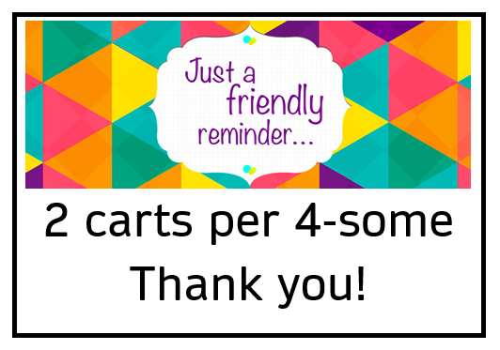

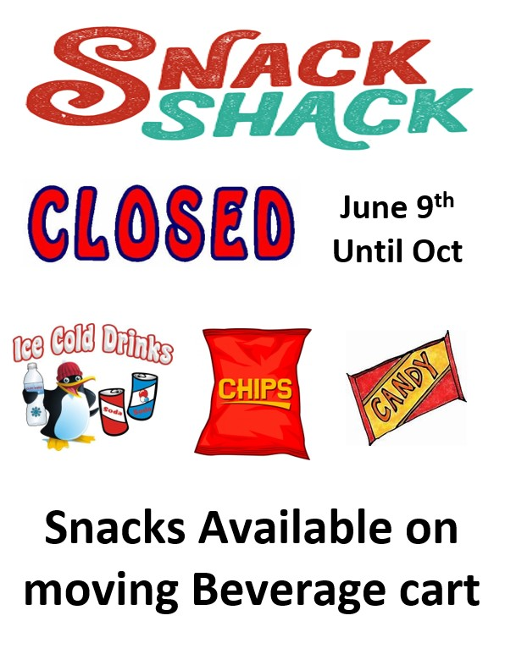

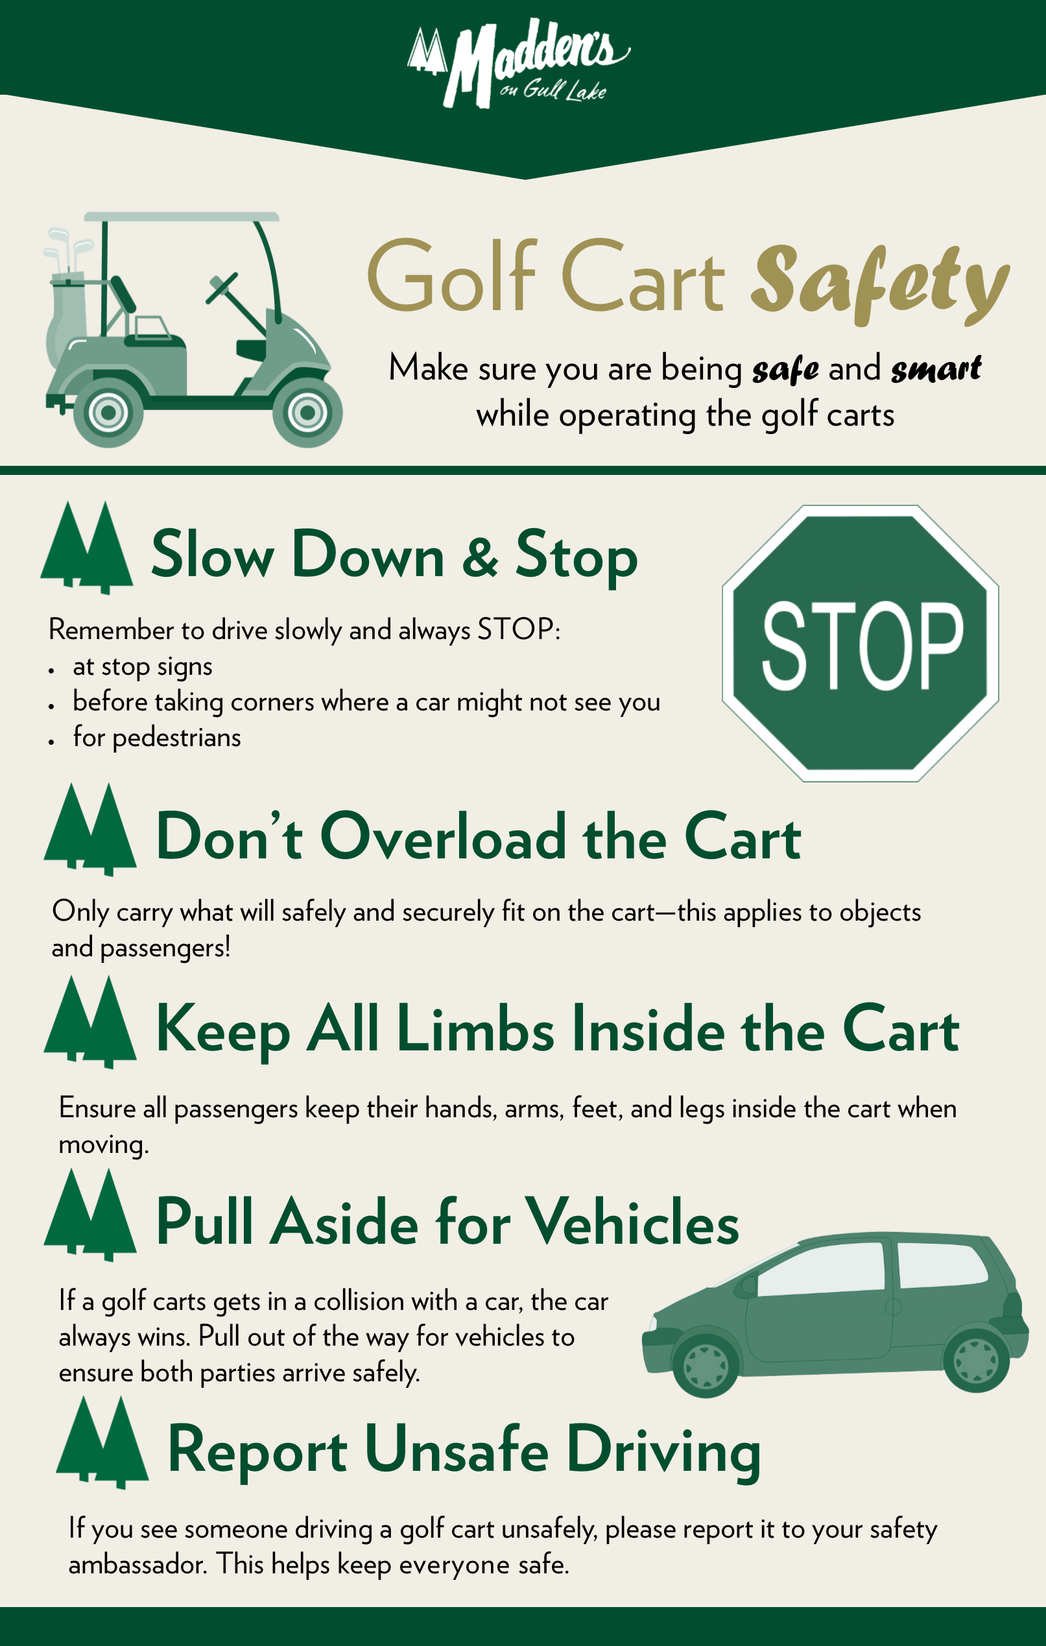





**2025 Club Champions**

